80% PAYBACK
PRIZE LIST $$$$$

1st PLACE TEAM $2150
2nd PLACE TEAM $1500
3rd PLACE TEAM $1050
4th PLACE TEAM $750
5th PLACE TEAM $550
Based on 50 Boats

Remaining teams will be entered into drawing for a free entry into 2025 tournament.
MUST BE PRESENT TO WIN
BIG BASS POT PAYS 100%
(Entry Fee includes $10 towards Big Bass Pots) 1st Place Big Bass $350, 2nd Place $150 Based on 50 Boats

LOCATION: Lake Wisconsin Launch wherever you want Pre-Tournament Meeting: 7:00AM
@
TOURNAMENT HEADQUARTERS:
Sunset Harbor Bar and Grill
N2103 WI-188, Lodi, WI 53555
TOURNAMENT HOURS:
1st FLIGHT TAKEOFF APPROX 7:30 AM CONTINUOUS TAKEOFF
WEIGH-IN STARTS AT 3:30PM
Late = Disqualified
One member from each team must attend the pre-tournament meeting.

29th Annual
SPRING FLING
Saturday April 20, 2024 on Lake Wisconsin
$160/Boat
Includes Big Bass Pot

5 FISH LIMIT
Pre-paid entries will receive priority take off spots!
check out our NEW website:
www.madisonbassclub.org

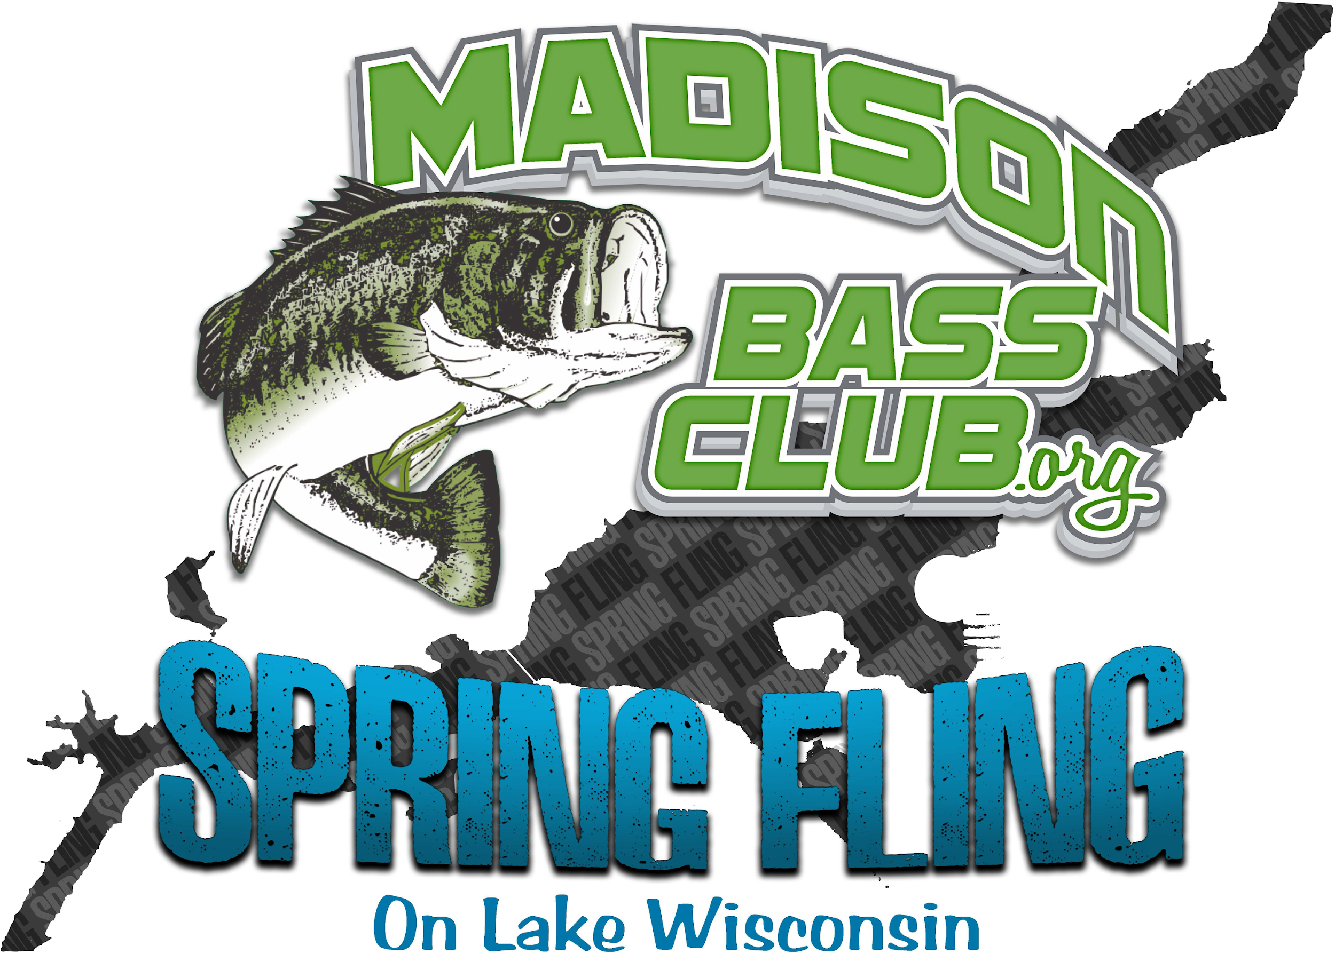

PRESENTED BY

Saturday April 20, 2024
Sunset Harbor Bar and Grill
On Lake Wisconsin

Contacts: Chase Dietrich: 309-573-8424

SPRING FLING 2024 OFFICIAL ENTRY FORM
Partner 1: (Please Print)
Name Address
City State Zip
Phone
Email:
Boat Reg.#

Partner 2: (Please Print)
Name Address
City State Zip
Phone
Email:
Each team is responsible for supplying its own boat and launch fees according to the rules and regulations outlined in this brochure. We have read and understand the Madison Bass Club Tournament Rules and would like to enter the contest. In signing this application, we hereby waive and release all other contestants, the hosts, sponsors and tournament officials from all claims of injury and/or damages which may be incurred in connection with this tournament. We further understand and agree tournament officials reserve the right to refund this entry fee if for any reason they decide not to accept this application. We swear the above facts we have represented to be true and accurate to the best of our knowledge. All contestants may be subject to a polygraph test.

Partner 1:

Signature Date

Partner 2:

Signature Date
Make checks payable for $160 per Boat (Includes Big Bass) to:
Madison Bass Club:
689 Porter Rd
Evansville, WI 53536
SEE WEBSITE FOR DETAILS
RULES: Interpretation of these rules shall be left exclusively to the Tournament Committee. Their decisions will be final in all matters
SPORTMANSHIP: Competitors are expected to follow high standards of sportsmanship, safety and conservation. Any infraction of these fundamental principles may be deemed cause for disqualification. Any act of a competitor which reflects unfavorably upon the effort to promote fisheries conservation, clean water and courtesy shall be reason for immediate disqualification. No alcoholic beverages, stimulants or depressants will be allowed during the tournament.
BOATING CONDUCT: Safe boating must be observed by all tournament competitors. Each competitor is required to wear a Coast Guard approved chest type life preserver (PFD). It must be strapped, snapped or zippered securely and maintained in that condition until the combustion engine is shut off. Violation of this rule is immediate disqualification.
FISHING METHODS: Only artificial lures may be used. No live bait will be permitted. Only one rod may be used at one time. Motor trolling or back-trolling are prohibited.
REGULATIONS: All entrant competitors must comply with all Coast Guard, Dane County Sheriff and Dept. of Natural Resource regulations. Any competitor receiving a citation for violation of any Federal, State or local regulation will be immediately disqualified.
BOAT AND MOTOR: All boats must be at least 14 feet in length and have all required safety equipment. The horsepower of the outboard must not exceed the maximum rating specified on the rating plate of the boat. All boats must be equipped with an ignition kill switch. All boats must be equipped with an operating live well to adequately maintain the catch.
BOAT IDENTIFICATION: Prior to the start of the tournament, each boat will be inspected by tournament officials and will be given a number which must remain in the boat until the end of the tournament. This number must be displayed upon request of tournament officials and turned in at the end of the tournament.
FISHING AREAS: Fishing on the tournament waters is not allowed within 50 feet of another competitor’s boat which is first anchored. No such anchored boat shall permit selected competitors to fish within the 50 feet circle claimed by such anchored boat. A competitor may not block a navigable channel. All angling must be done from the boat. Competitors must not depart the boat to land fish. Boats must remain in the tournament waters during the tournament hours. Trailering of boats during tournament hours is prohibited. Competitors must leave and return to the official checkpoint by boat. Both competitors must remain in the boat at all times during the tournament except in the case of emergency.
SCORING: Tournament standings and final winners will be determined by the total weight of each team’s catch. The tournament limit will be five (5) bass per team. Only largemouth and smallmouth bass are eligible for weighing. Bass must measure 14 inches in length or more with the mouth closed and tail fanned to the longest position. Bass presented for weigh-in which fail to measure 14 inches in length will results in disqualification. Any bass that appears to have been mangled, mashed, mauled or otherwise altered will be weighed at the discretion of the tournament officials. Any dead bass presented for weigh-in will receive a 12 ounce penalty. All fish presented for weigh-in become property of Madison Bass

LATE PENALTY: LATE IS LATE AND MEANS DISQUALIFICATION.
TIES: Big bass breaks total weight tie, total weight breaks big bass tie

